*** PRO RATES/PACKAGES DIFFER FROM COLLEGE HS PRICES LISTED ***
The Following prices listed are for Middle-School, High-School, and Collegiate Athletes
SESSIONS AT GMG LOCATION DOWNTOWN
- Zephaniah Moore Session Rates (90 minutes)
    - Private (1 athlete) = $100
    - Semi-Private (2-5 athletes) = $65
    - Group + Strength (6+ athletes) = $55
- Jonathan Jossell Session Rates (90 minutes)
  - Individual Sessions $75 (1 Athlete)
  - Semi-Private Sessions $45 (2-5 Athletes)
  - Group Sessions $35 (6+ Athletes)
- Nate Jossell Session Rates (60 minutes)
  - Individual Sessions $45 (1 athlete)
  - Semi-Private Sessions $35 (2+ athletes)

SATELLITE SESSIONS (at another location such as home gym, church, etc.)
- (60 MIN SESSIONS) – This does NOT include any injury prevention or mobility
  - Session Rates
    - Private (1 Athlete) = $75
    - Group Sessions (2+) = $55 per athlete
COLLEGE PLAYERS
- $40 per athlete for any group larger than 2
- $75 for individual sessions.
SHOOTING CONSULTATIONS
- $75- for an individual shooting consultation – will include an hour of shooting instruction, form, technique, and film breakdown.

*** SEE BELOW FOR PROFESSIONAL PLAYER & TEAM PACKAGES ***
PROFESSIONAL PLAYERS (Post-Collegiate)
- Individual Packages Vary on TIME and COMMITMENT
  - Resources and Packages CAN include, but are not limited to:
    - Full Basketball Performance and Skill acquisition
    - FULL and Individualized Strength and Conditioning Programming
    - Mobility/Functional Range/Injury Prevention Programming
    - Personalized and Detailed Film Breakdown
    - Professional Private Runs
    - Nutritional Plans
    - Access to gym and shooting circuits
  - Prices are based on a “Per Week” basis and structured week to week.
PROFESSIONAL SATELLITE SESSIONS
- Package varies on length of time spent away.
  - Payment can include the following, but it must be covered or agreed upon within the payment total for training on site:
    - Place of stay for total duration
    - Travel Expenses (gas or flights & transportation at location)
    - Transportation agreement (this includes to and from the airport)
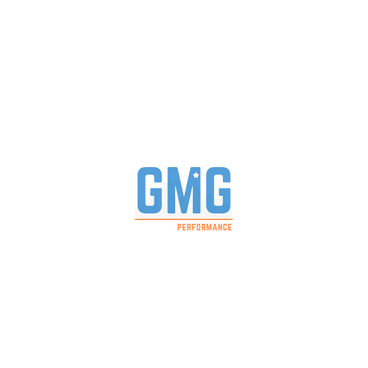
    - *** In addition, *** if training is taking place where a flight is necessary to get to the destination, all equipment outside of bands and basketballs must be provided. This INCLUDES a place to train in an equipped weight room.
  - Sessions are then booked for the totality of the trip, invoice is sent and paid for prior to departure.

TEAM RATES
- For a FULL TEAM (or position specific work) a session will run 90 minutes long and include 60-70 minutes of basketball, with a 20-30-minute functional range and mobility cool down. If there is less than 8 players, the group rate of $45 an athlete will apply. If there is 10+ (with a cap at 15), total for the 90-minute session = $350 for the entire team.

